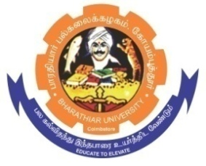
ghujpahh; gy;fiyf;fHfk;
BHARATHIAR UNIVERSITY
COIMBATORE – 641 046, TAMILNADU, INDIA

State University | Re-Accredited with “A++” Grade by NAAC | Ranked 21st among Indian Universities by MHRD-NIRF

e- TENDER INVITING NOTICE

E-Tender Notice No: BU/R-D8/616/Chemistry.st.table/2023-24 Date : 09.03.2024

Online Bids are invited through Tamil Nadu Government e-Procurement Portal website: www.tntenders.gov.in Tenders by Organisation Higher Education for the Purchase of 6 Nos. of Steel Executive Table for the Department of Chemistry in Bharathiar University, Coimbatore.
The Tender documents can be downloaded from 09.03.2024. Bid submission will be started on 09.03.2024 and will be closed on 22.03.2024 @ 03.00PM.

REGISTRAR i/c

Website: www.b-u.ac.in E-Mail: regr@buc.edu.in Phone: 0422-2428108/2428126 Fax: +91 422 2425706

